**Assignment4 Analysis Report**

* Xiaowei Wan

1.correlations with G1 value:

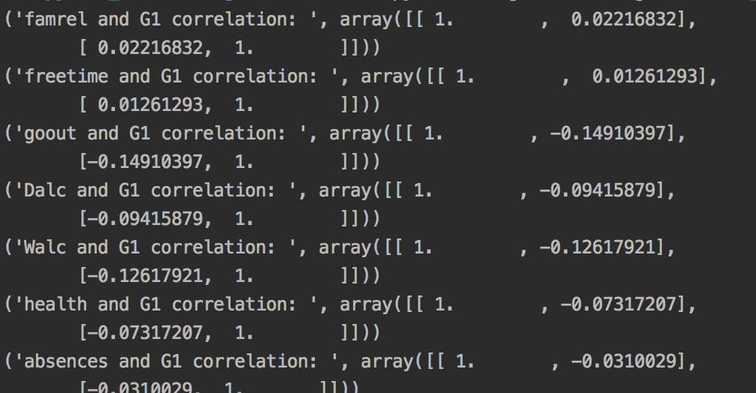

* correlation value of famrel and G1 is 0.0221, very small, no correlation, quality of family doesn’t have strong affection of student G1 score.
* Freetime and G1 correlation is 0.012, very small, no correlation, free time after school doesn’t have strong affection of student G1 score.
* Gout and G1 correlation is -0.149, small, going out with friends doesn’t have strong relation with student G1 score.
* Dalc and G1 correlation is -0.09, small, Workday alcohol consumption have weak relation with G1.
* Walc and G1 corrrelation is -0.12, small, Weekday alcohol consumption have weak relation with G1.
* Health and G1 correlation is -0.07, negative correlation.
* Absences and G1 correlation is -0.031, negative and weak correlation.

2.scatters with G1

